Until this point we have studied about Computer Vision. Where we have processed images and videos to classify objects in them or find their location.

Next is NLP , here we deal with text or language data where we deal with text data i.e. (language data) , Human Speech Data (eg reviews on ecommerce). Natural Language is human speakable / understandable language. Now machine cannot understand human language instead can understand machine language i.e. binary numbers 0 and 1.

So main idea in NLP is to convert text into numbers which can be easily converted into binary and vice-versa.

For eg as in ML we try to convert object datatype into numbers. In the same way since we r having all text data here, we r trying to find a way to convert text into numbers which we exactly try to learn in NLP.

For eg ChatGPT , generates text ,gives answers in human understandable language only.

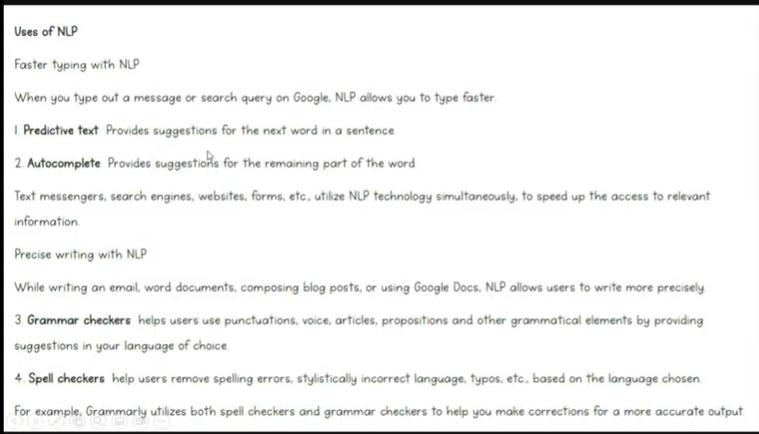

In predictive text, suggests 4-5 words based on current word and auto complete, completes remaining part of the word. Grammar checkers and spell checkers in precise writing is done by tools such as Grammarly. Furthermore uses of NLP-

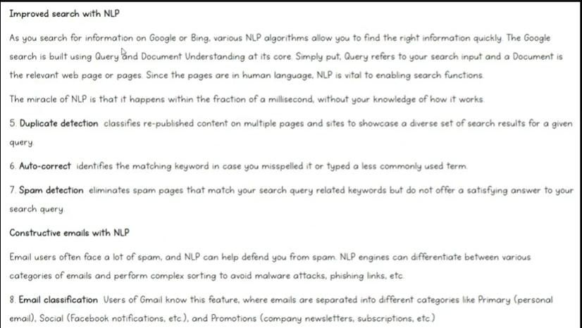

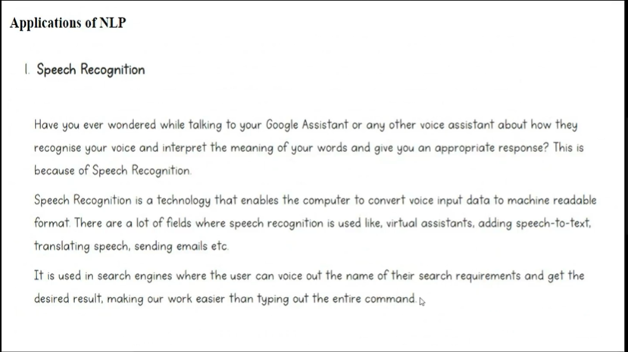

In Speech recognition, NLP converts speech to text and then proceed further.

Then we have voice assistants ad chatbots.

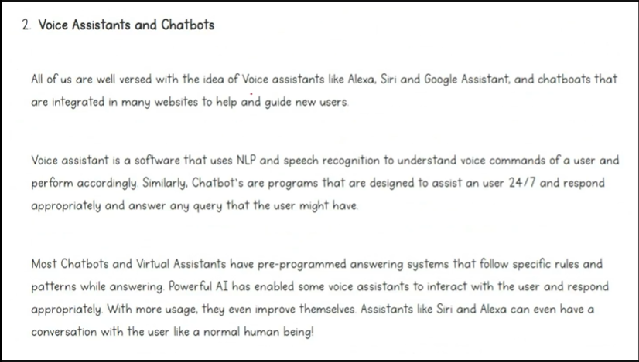

For eg GPT-4O Omni model can speak too. In the same way Alexa, Siri and all work.

Some similar applications include Email Filtering i.e. spam or not spam, sentiment analysis.

Targeted Advertising to Audience based on the products u have searched. Language translation from hindi to English, etc , in recruitments with the help of ATS (Application Tracking System) .

So we have NLG and NLU as subpart of NLP. Natural Language Generation eg ChatGPT and Natural Language Understanding eg Sentiment Analysis.

In NLG , we r generating human like text. NLU is where it tries to understand what human actually means i.e. trying to understand intentions of user.

55:09 intro to NLP

NLU is more deficult than NLG because of lexical ambiguity, syntactic ambiguity and referential ambiguity.

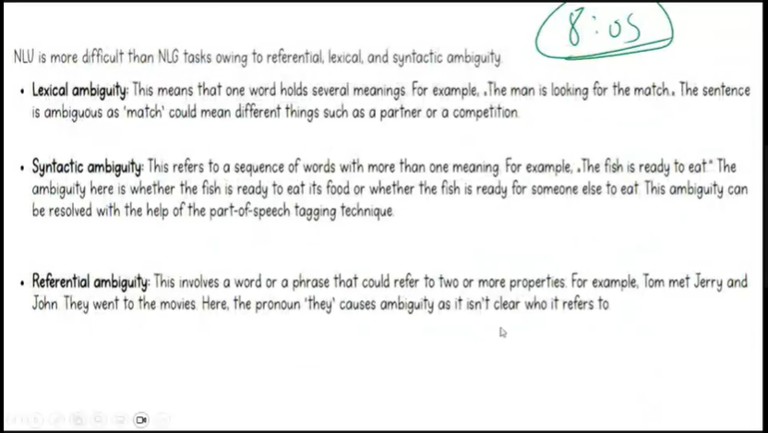

Lexical ambiguity deals with word that holds several meanings. For eg the man is looking for the match. So match here holds many meanings like partner or competition.

Then, syntactic ambiguity where the sentence can have more than 1 meaning. Lly, referential ambiguity where it is not clear in the sentence who is referred.

Next is Stages of NLP-

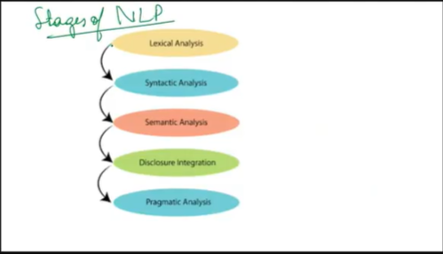

Lexical analysis is word level analysis. It is of 2 types. Stemming and Lemmatization. **Stemming** and **Lemmatization** both reduce words to their base form, but they differ in approach:

* **Stemming** : Cuts off word endings (e.g., *running* → *run*, *flies* → *fli*). It may not always produce meaningful words.
* **Lemmatization** : Converts words to their dictionary root form (e.g., *running* → *run*, *flies* → *fly*), considering context and grammar.

Syntactic analysis is sentence level analysis. i.e. checking grammar and syntactical meaning of words and relationship between them.

Semantic Analysis means meaning of sentence.

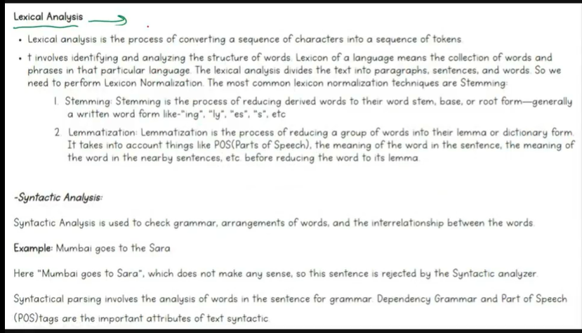

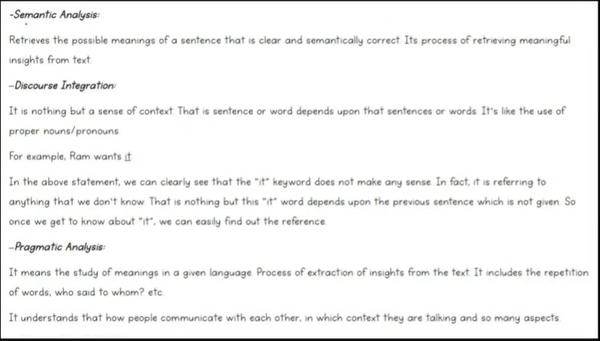

Discource integration is like referential integrity. For eg Ram wants it. So it here is what? So this makes sure that context of the reference is correct.

Pragmatic analysis tries to understand the context of the conversation.

Next is there are some jargons that we use in nlp. So, 1 is corpus, another one is document.

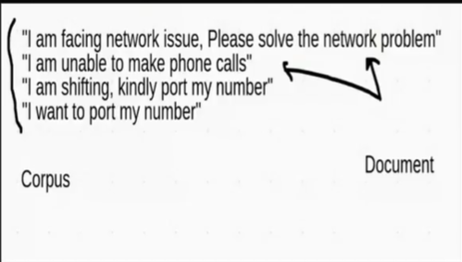

In the above picture 4 documents are there. The collection of documents is called as a corpus. So in NLP we don’t call them sentence instead we call them documents. Now collection of sentence is called as a Paragraph, but here collection of documents is called as corpus.

Next is coming to the practical part. So 1st is text preprocessing.

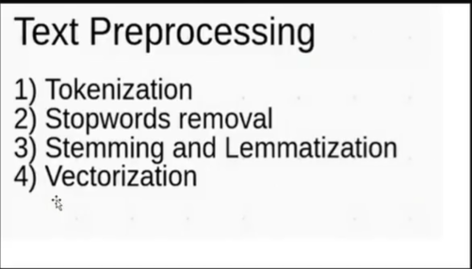

By text preprocessing we mean cleaning of data. Extraction of features.

There are few other steps too like

5.Parts of Speech Tagging (POS), 6. Named Entity Recognition (NER) 7. Wordcloud

Where steps 5,6, and 7 are optional.

So next Understanding Tokenization.

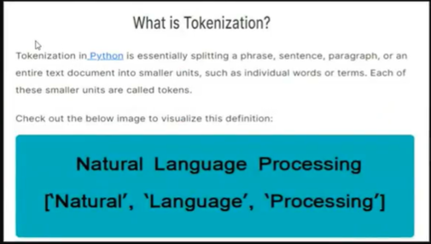

i.e. breaking sentence into words.

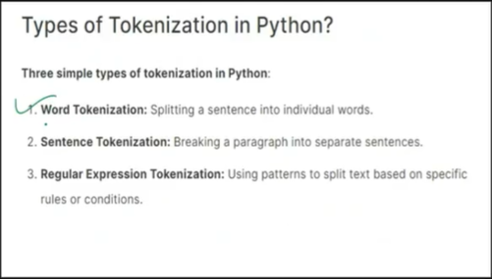

Text_preprocessing.ipynb

POS Tag List—

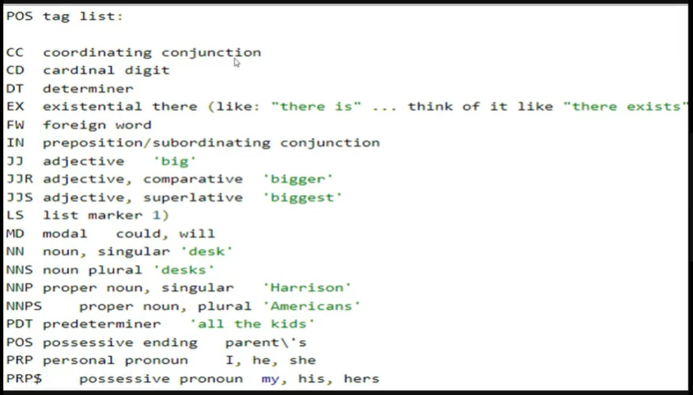

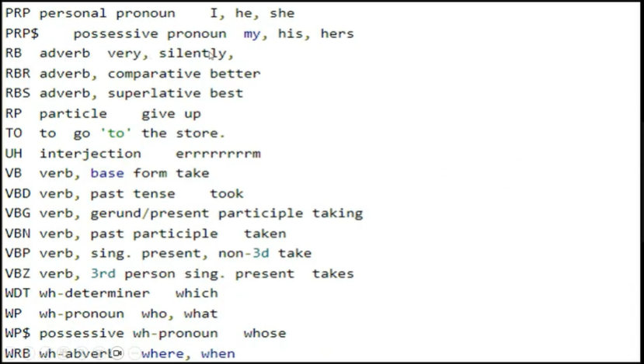

Next is NER—

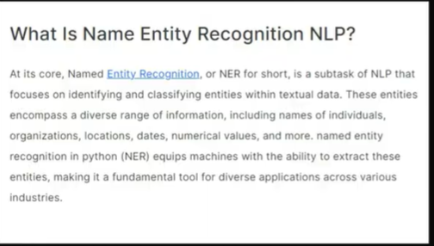

So, NER list is like—

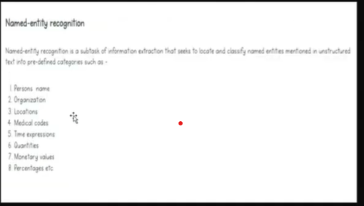

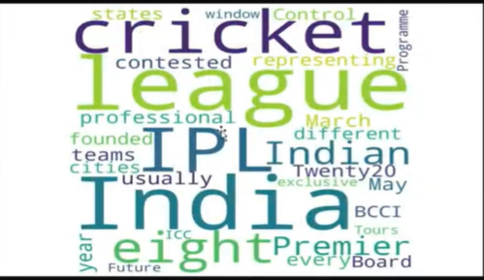

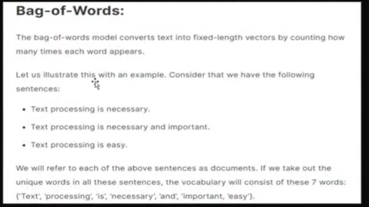

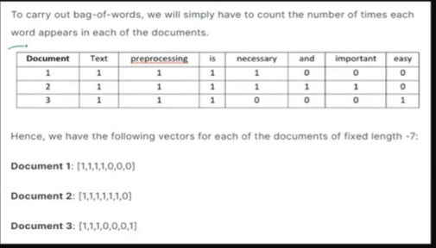



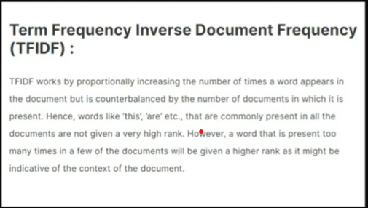

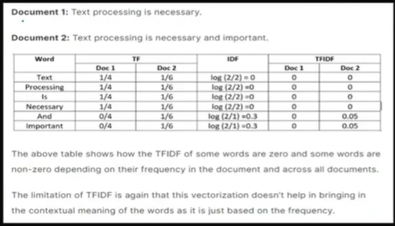

Next will be Text_Classification.ipynb

Embeddings are vectors in higher dimension.

And same vectors will have same meanings.

These are numbers only. It gives words which are close in meaning nearly same numbers.

There r 2 ways to create embeddings. 1. word2vec model, 2. Keras embeddings.

Use keras embeddings, if u r creating NN model.

otherwise u can go with word2vec model and then apply it on some ml model.

word2vec-- either use pre-trained embeddings or u can even train embeddings.

The assumption of word2vec is The meaning of word changes depending on other

words in a sentence. for eg data in I am a data scientist. I know AI.

or war in world war,civil war, cold war.

Now there r 2 types of algorithms in word2vec.

CBOW and skip gram.

CBOW is continuous Bag Of Words.

SO By CBOW, on a sentence, I am a Data Scientist. I know AI

so , if windowsize, vector size and wordcount are

hyperparameters that we need to decide. if windowsize=1, then 3 words pair

containing I am a will be created, then I and a will be a context and

am will be a target. so I and a will be a pair which is used to predict middle

word on the basis of neighbouring words.

Then this window will slide and will contain am a data.

so am and data will be used to predict a i.e. we can write this as--

(I,a)->am

(am,data)->a

(a,scientist)->data

(data,and)->Scientist

In case the window size=2,

then total 5 words will used instead of 3

and middle word will be a target and rest will

be used as a context.

In pretrained embeddings, google has trained 3 billion tokens.

So if u will give a particular word to this model, it will give the embedding.

See word embeddigns.png

Pretrained model is trined by Google.

Now humain brain can visualize well till 3 dimensions x,y and z.

But embeddings can be of 100 dimensions. Where same meaning words have

similar numbers.

Word2vec model can be trained with the help of CBOW - continuous bow

and skip gram.

Skip gram is kind of opposite of cbow.

So here take as i/p middle word and o/p

neighbouring words based on i/p words.

Now we r not storing frequency instead meaning

of am and I.

So we will try this with ML and DL (ANN) model.

Lets suppose we have an email which contains text and we have classify whether this email is

spam or not.

In the next week u have to submit assignemnt of human vs horse assignemnts using cnn,

Link for downloading GoogleNews-Vectors

<https://drive.google.com/file/d/0B7XkCwpI5KDYNlNUTTlSS21pQmM/edit?resourcekey=0-wjGZdNAUop6WykTtMip30g>

U can also find this link in geek for geeks. Search Pre-trained word embedding in NLP or

word embeddings word2vec

TextClassification.ipynb 8th July 29:00

#---------------------------------------------------

Next is Sentiment Analysis using ANN-----------

What is sentiment analysis—it is also a usecase of NLP, where text is classified. Here text is classified into +ve , -ve and neutral.

The ultimate goal of sentiment analysis is to decipher the underlying mood,

Emotion or sentiment of a text. This is also referred to as Opininon Mining.

|  |  |
| --- | --- |
| X_train.shape = (29941, 300) | 29,941 padded sentences, each with 300 word tokens |

|  |  |
| --- | --- |
| input_dim=vocab_size | Number of unique tokens + 1 (for padding) |

|  |  |
| --- | --- |
| output_dim=100 | Each word becomes a 100-dimensional vector |

|  |  |
| --- | --- |
| input_length=300 | Tells Keras each input has 300 tokens |

|  |  |
| --- | --- |
| Output shape | (29941, 300, 100) — ready for RNN/CNN/etc |

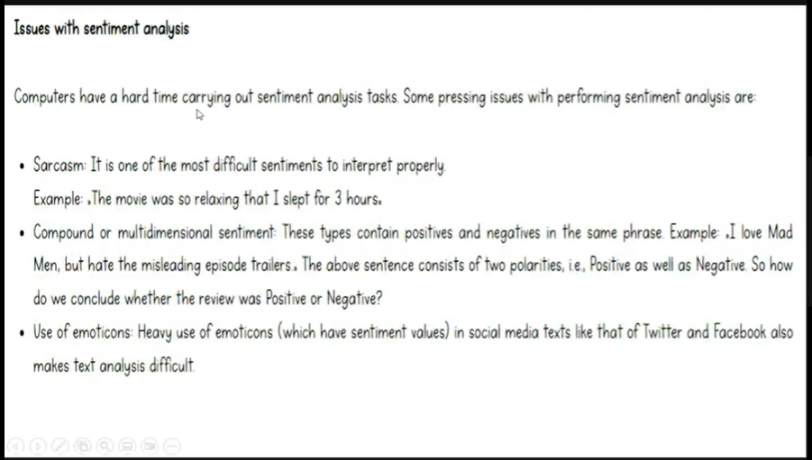

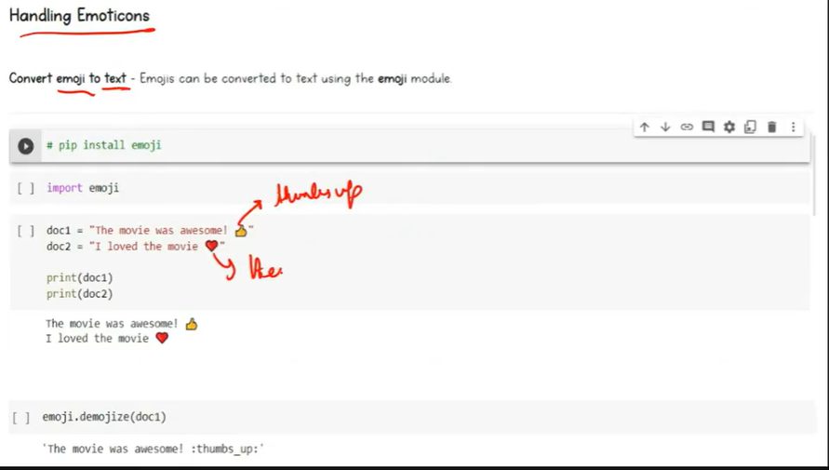

So in above we have converted emoji into text.

The 2nd way is to completely remove them. For eg.

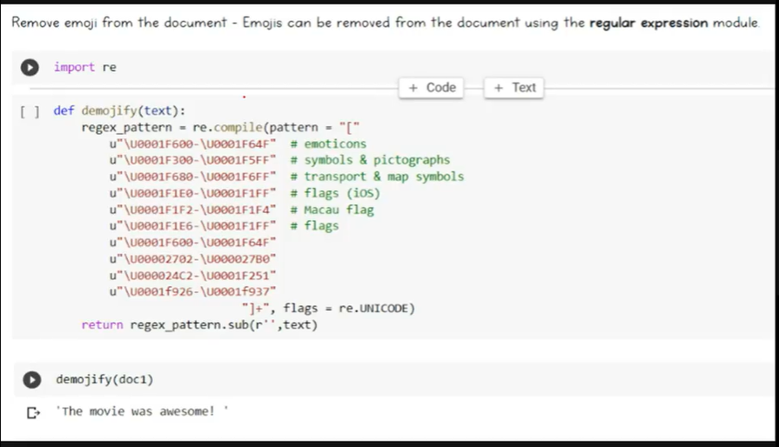

In the regex_pattern.sub(r’’.text )—we r substituting by blank text.

So, we r using word2vec and keras embedding layer, as BOW and Tf-IDF are inefficient.

So here we have 3 sentiments. +ve , -ve and neutral.

So it’s a multiclass classification problem.

o/p layer activation func is – softmax.

Sentiment_analysis_using_ANN.ipynb-----------------------------------------

27:00 rnn 10th July

**🧠 What Is a Simple RNN?**

A **Simple RNN** is like a person reading a sentence **one word at a time** and remembering what was said before. It **updates its memory (called hidden state)** with every new word, then uses that memory to make a decision.

**🎓 Simple RNN Formula (One Step):**

When the RNN reads one word (i.e., one time step), it does this:

h_t=tanh(W_x⋅x_t+W_h⋅h_(t−1)+b)

Where:

* h_t = new hidden state (updated memory)
* x_t​ = input word (vector from embedding)
* h_(t-1)​ = previous memory
* W_x​, W_h = weight matrices
* b = bias
* tanh() = activation function (squashes values between -1 and 1)

**📦 Parameter Calculation Formula:**

For an RNN layer:

Total Parameters=(input_dim+units+1)×units

Let’s break this down simply.

**✅ Example:**

Suppose:

* Input vector from embedding = 5 numbers → input_dim = 5
* We want the RNN to remember 32 things → units = 32

Now plug into the formula:

(5+32+1)×32=38×32=1216 parameters​

This includes:

* **Input weights**: W_x
* **Recurrent weights**: W_h​
* **Biases**: bbb

**💡 In Simple Words:**

* RNN reads one word → combines it with its memory → updates memory.
* It does this **again and again for each word**.
* It learns how much of the past to keep and how much to forget.
* All learning is stored in **weights**, which we calculate as shown.

Different types of RNN are

Many-to-one

One-to-may

Many-to-Many . It is of 2 types—fixed length and not fixed length.

Simplest of all is –

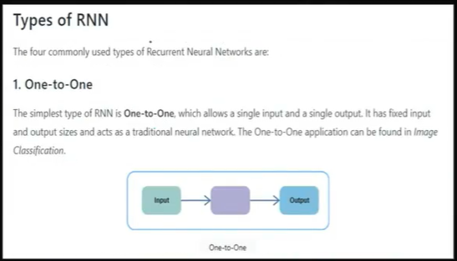

It is not even considered in RNN NLP, instead can be used in Image Classification.

Next is One-to-Many:

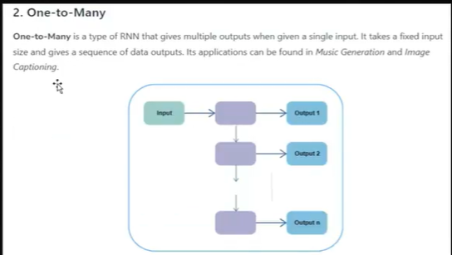

Here, in i/p we give non-sequential data, while in o/p we give sequential data.

For eg Image Caption Generation. i.e. lets supoose as i/p we r giving image . So image

Is a single image nothing before or after. Now in the image lets suppose a person is running.

So, the o/p of this model will be like one person is running. i.e.

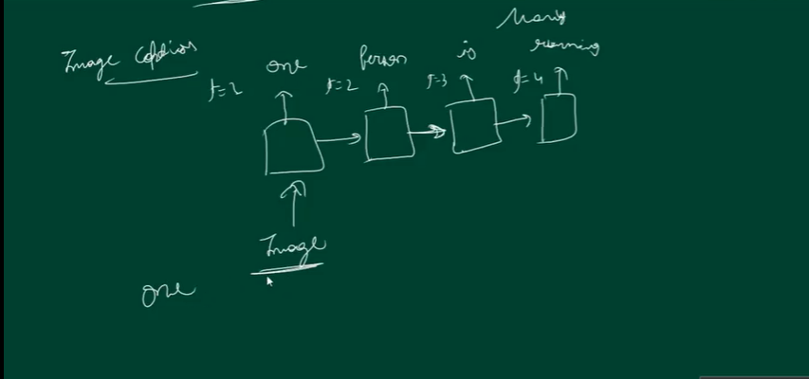

Next is Many-to-1 –

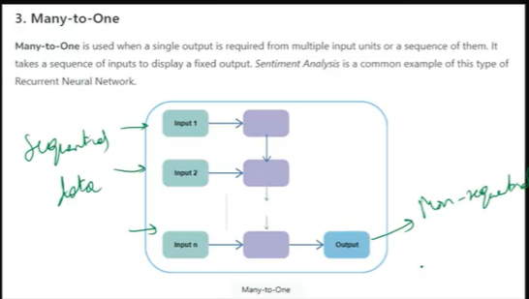

for eg Sentiment Analysis. i.e. as i/p we are giving Movie was Good and as o/p we r

getting 1/0.

Next is Many-to-Many.

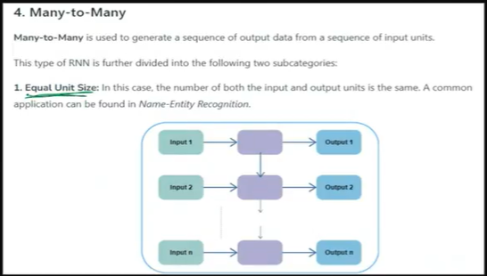

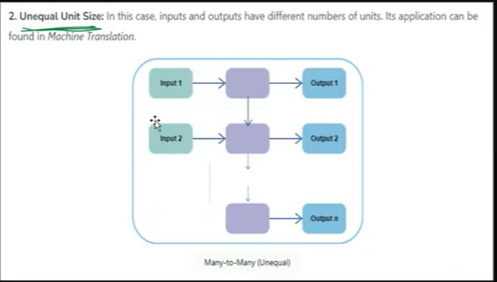

This many-to-many(Unequal) is called As Sequence-to-Sequence Model i.t. Transformers on

which chat-gpt is based.

Applying sentiment_analysis_simpleRNN.ipynb

RNN 11th July ---

Problems in RNN— 1. Vanishing/exploding gradients.

2. Cannot handle Long term Depedency.

For eg. 1.Maharashtra mother tongue is Marathi. 2. Maharashtra in in south west location

Of India. It is a beautiful state. People here are very hard working. They speak Marathi.

Now, Maharashtra is the 1st word and Marathi is almost last. So this is long term dependency.

Now, why is it unable to handle long term dependency , for that we will have to understand

Some maths. So understanding both the problems by maths.

Now, the activation func used in RNN is tanh and not relu.

29:29 RNN 11th July

Next is total parameters at each timestamp—

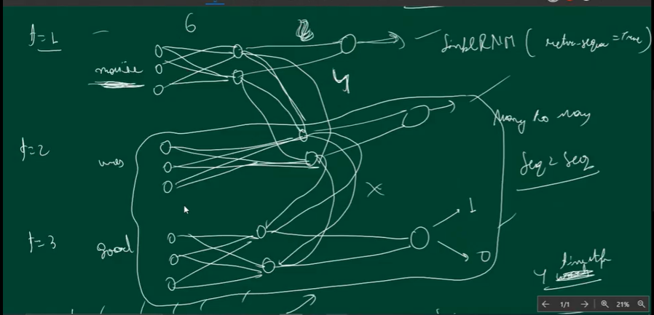

i.e. 6+4+2=12 weights and 3 biases = 15 trainable parameters.

Now, because of vanishing gradient problem, RNN can’t hold long trerm dependency.

Note—RNN isnot recommended for long sentences.

Instead use LSTM , GRU or transformers.

The bigger the o/p dim in model, the more the vanishing gradient problem.

Now tanh has a problem of vanishing gradient, where as relu has a problem of exploding gradients.

In exploding gradients, the weights become very large for eg 1.5*1.5=2.25*1.5=3.375

This results in never ending training and so weights keep on updating because new weight=old weight.

Best weights are when wnew=wold.

So we can say rnn has short term memory.

Now, LSTM –

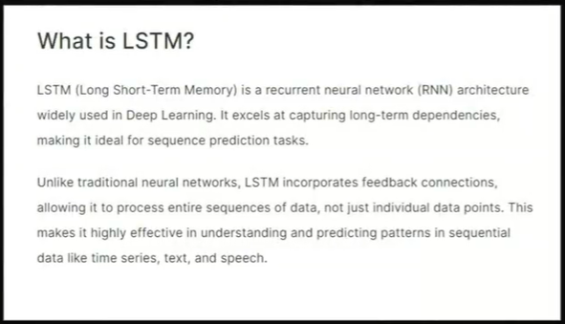

LSTM Architecture—

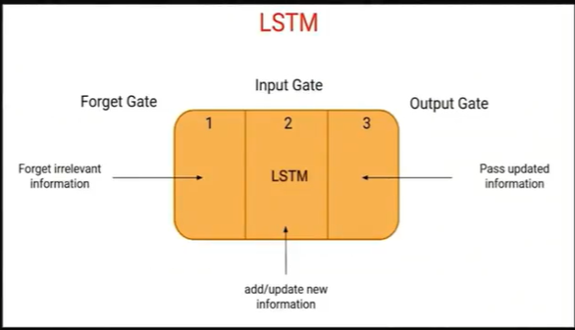

More in-depth architecture—

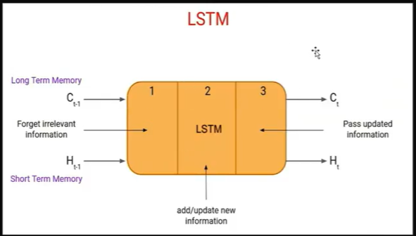

Where, C is cell state, and H is Hidden State.

Now C contains long term memory to store long term memory.

The short term memory, given by H, go through each word, and if

It thinks the word is imp then puit it in long term memory.

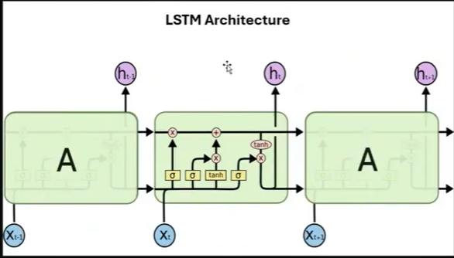

Especially considering this,

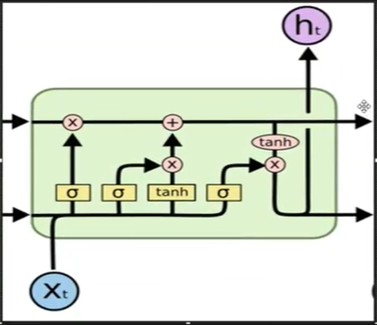

Here , upper input is for Long term memory Also called as Cell State.

And lower is Short term memory. Also called as Hidden state.

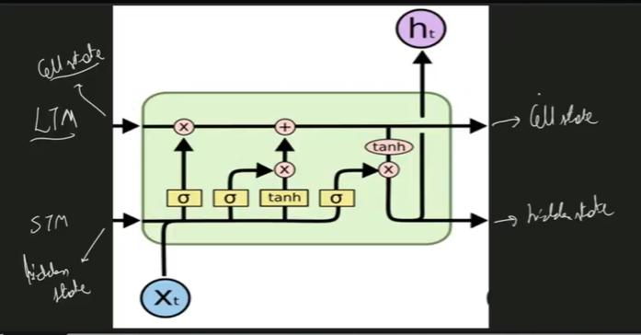

Short term memory o/p is given to next timestamps whereas, ltm memory o/p

Is present till the end timestamp.

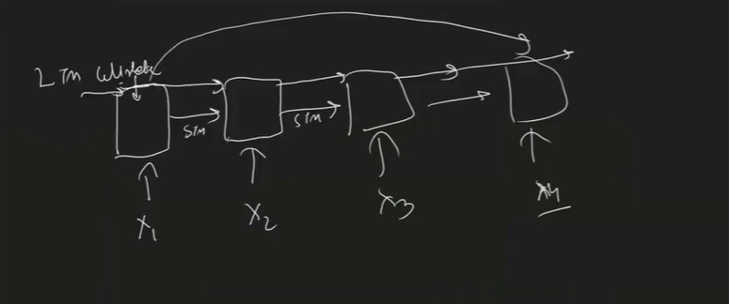

28:49 – LSTM 15th July.

Whatever in stm, it feels is important, it keeps in ltm.

Now LSTM has 3 gates for maintaining information flow.

They are Forget gate, i/p gate and o/p gate.

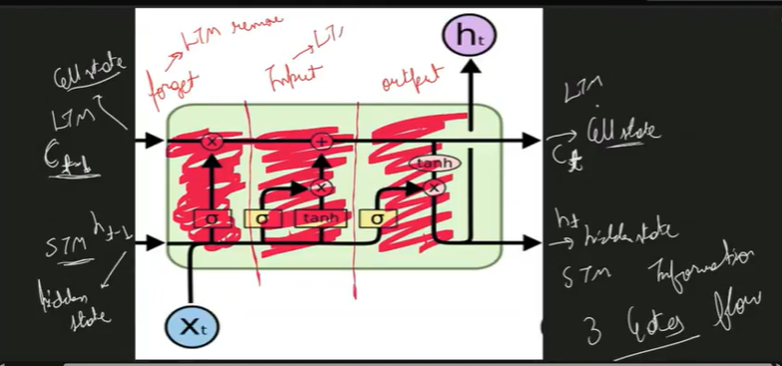

Forget gate is to remove something from ltm. Input gate is to put something on ltm.

And o/p gate is to decide the word will go in longe term memory or short term memory.

X_t is the timestamp. c_t-1, h_t-1, they are cell state and hidden state . f_t, i_t , c_bar_t and o_t are also there. 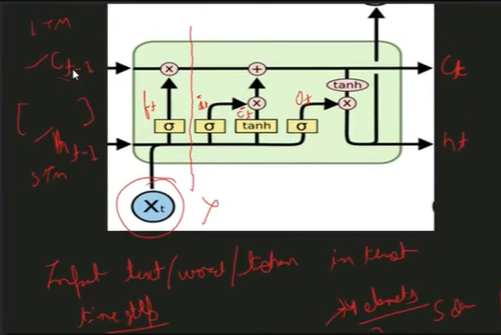

They all are vectors or numbers of same shape. i.e if c_t-1 has 3 items like, [4,1,3] then all the other vectors will also have same shape. X_t however can be of any shape eg 100,200 etc as these are embeddings. But rest of them has similar shapes.

Now c_t_bar is a candidate cell state. i.e. it is the item which we can add in long term memory.

F_t contains that which can be forgotten, i_t contains input number, o_t is output

H_t-1 is short term memory from previous timestamp, c_t-1 is long term memory.

Lets suppose the sentence is Vikramaditya is Powerful. Then t1 for Vikramaitya , t2 is t3 powerful.

Next are operations i.e.

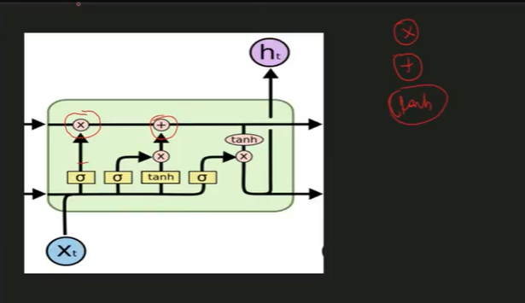

Its point wise multiplication, point wise addition and point wise tanh.

Eg of point wise multiplication –

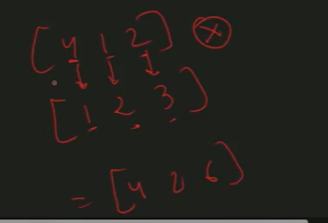

Point wise addition = [5 3 5] lly, point wise tanh = is hyperbolic tangent – gives values between -1 to +1. Next understanding yellow boxes—these are artificial nn layers with activation function sigmoid or tanh.

Now first talking about forget gate f_t – The architecture of forget gate is like—

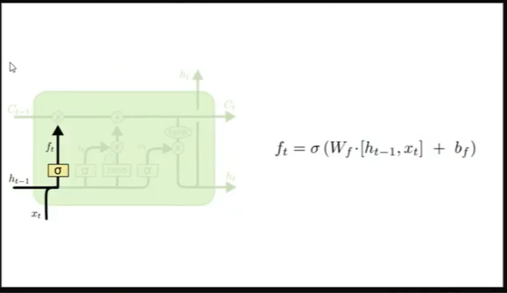

We have h_t-1 , x_t and sigmoid here. H_t-1 is short term memory from previous timestamp. X_t is input from current timestamp.

Now lets suppose word is nice, whose embedding is of size 4 i.e. [4,1,2,3] . Now lets suppose h_t-1 shape is 5 i.e [1,2,3,4,5] . Now this shape can be different then x_t. the sigmoid is the nn layer with units 3. Then the shape of h_t-1 will also be 3 as the shape of h_t-1 depend on the number of units in sigmoid layer. Now it’s a fully connected layer. Now f_t will have same number of items or shape as number of units in nn layer.

Next after f_t calculation, it will be point wise multiplied with c_t-1. Now c_t-1 shape is same as h_t-1 i.e. 3. Now if c_t-1 =[4,2,6] and f_t-1=[0.5,0.5,0.5] since sigmoid only gives values from 0-1. So point wise multiplication gives {2,1,3] i.e. we lost certain information. If f_t value is 0 then everything in c_t-1 will be 0, And if the machine thinks the information coming from c_t-1 is important then f_t value will be 1.

Lstm 16th July----------

In rnn, we were facing issues of not understanding Long term depenedencies.

LSTM is the updated version of rnn. So the 3 gates of rnn are forgetting info from long term memory. Next is i/p gate or update gate where we update info to ong term memory. Next is output gate. Here

We have cell state that deals with long term memory, Hidden state t deal with short term memory.

Input can be of any size but all the other vectors will have same size , same as number of units in sigmoid layer. Same with tanh.

So now lets discuss short term layer.

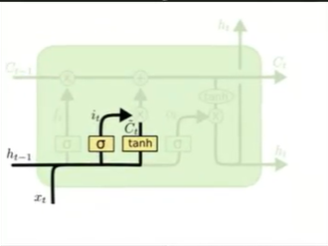

So 2 inputs h_t-1 and x_t is given to sigmoid and tanh layers.

Lets suppose X_t embeddings are of size 5. And h_t-1 is of size 3.

Now sigmoid o/p will be from 0 to 1 and tanh from -1 to 1. The o/p from sigma now becomes i_t.

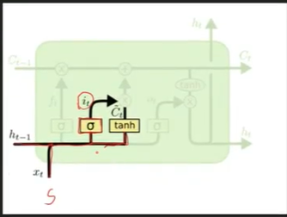

Till here f_t and i_t information is same. But f_t is given to long term memory to decide what is important and forget whats not and then go ahead.

Next is tanh . So I have predecided that 3 nodes will be there. And on all those 3 nodes, the activation function is tanh . The o/p of tanh is C_t_bar. This can contaong different values then f_t and i_t. C_t_bar is the potential candidate for long term memory cellstate i.e. C_t-1.

But before adding C_t_bar to long term it is point multiplied and filtered u can say by current i/p sigmoid value i.e. i_t. The wieights and biases of i_t and C_t are updated through backpropogation.

In RNN vanishing gradient problem is there, but in LSTM there is no vanishing gradient problem because different layers like sigmoid, tanh etc are working separately i.e. every nn is working differently and are not related to one another.

Next the o/p of point wise multiplication is given as i/p to point wise addition with long term memory. i.e. if c_t-1=[-0.5,0.5,1] and i_p and c_t o/p is [4,2,3] , then

[-0.5,0.5,1]+[4,2,3]=[3.5,2.5,4] So now for next timestamp this will become c_t-1 and given as i/p.

Next we have is o/p gates.

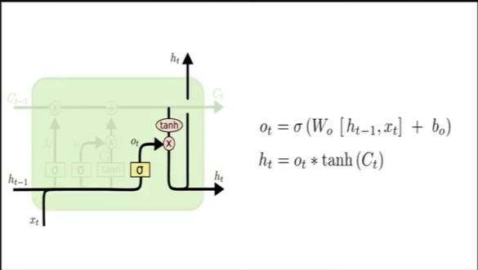

After o/p gate a chain of what we have seen is repeated for next words, like-

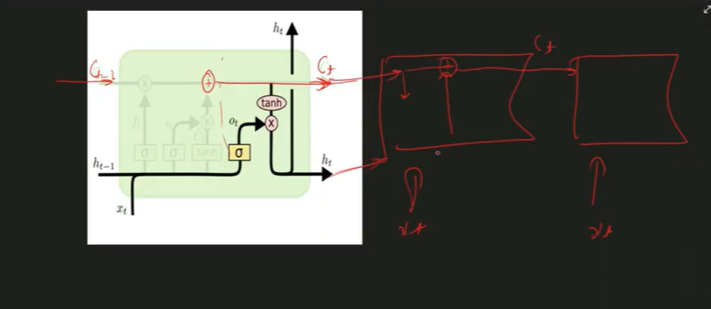

Now h_t is getting outputted from 2 places. The o/p layer also adds non-linearity

to the data. Now the below h_t as it goes to the next timestamp or word i/p we donot need it anymore. So because of that in h_t we only keep that much of information jitna next node ke liye important ho. So this is done using backpropogation. So as h_t-1 and x_t is given to sigmoid , o/p is o_t. o_t has only values from 0-1. On C_t values tanh is applied and point wise product of o_t and c_t is done to give short term memory h_t as o/p which will be i/p for the next cell.

Next the upper arrow h_t is to get o/p at every node. In RNN we have return sequences. If its value is True , then at every timestamp o/p will be given.

So in o/p layer we r deciding what to keep in short term memory so that the next node can use it.



Sentiment_analysis_LSTM.ipynb

Next is LSTM Next word Prediction. Data 1661-O.txt. lstm_project.ipynb . For this kind of work u need a very big dataset. It can be like for 8000 words training a GPU might take 1.5 hours where as a CPU can take 1-2 days.

Steps required – Data collection, Data Cleaning, tokenization,Vectorization then train the model.

LSTM 17th July

Next word predictor model.

GRU 18th July – Gated Recurrent Unit. The time required for training LSTM is lets say 10, then it will use only 4-5 mins and Its performance is same as LSTM . It doesn’t have any long term memory and has only short term memory. So try for both models while applying.

GRU has gates—reset gate and update gate.

Architecture of GRU-

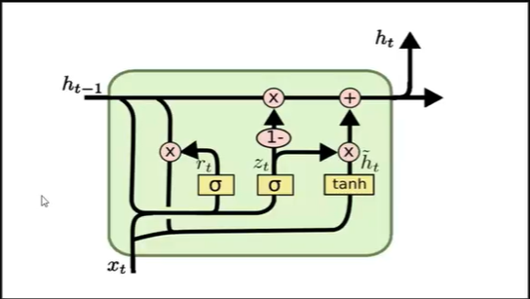

Here we have only 1 kind of memory i.e. hidden state h_t-1. There is no cell state.

This hidden state short term memory only acts as long term memory.

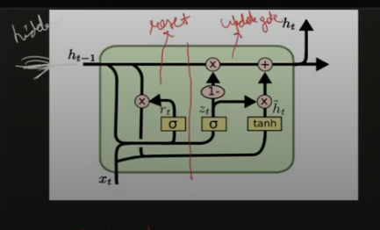

R_t is the reset gate and z_t is the update gate. Reset gate reset information from hidden sate. So based on current i/p x_t , reset gate resets information from hidden state.

Next is update gate updates information to hidden state. In the above picture, r_t is reset gate, z_t and h_t are update gates are vectors. And all of them have same sape. The rectangular nodes are nn layer with activation function sigmoid or tanh. X circle is point-wise multiplication. Decides how much infor should go ahead. Now 1- is point wise 1 minus.

So 1st reset gate – resets information from previous gate. Now lets suppose x_t h_t-1 are of same size 4. In reset gate the point wise multiplication of r_t and h_t-1 is very important. If r_t value is all 0 then the multiplication will result in 0 and information will be forgotten. If r_t is all 1 then all the info is important. So, reset gate decides how much info should go ahead.

Next is information going into tanh. i.e.

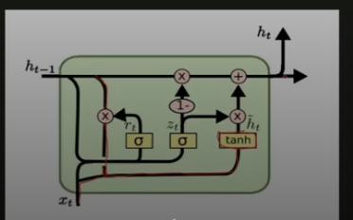

This is happening like-

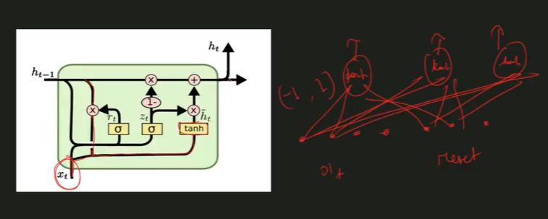

In lstm , we had c_t_bar which contains potential info to add on long term memory.

Here also, h_t_bar contains potetial info to add in memory. Now this h_t_bar info is ready to be applied on h_t-1 but after filteration. And that is why it is called as update gate.

Now h_t-1 and x_t is given as input to z_t. z_t is like a filter which takes care how much information should be added to memory in update gate.

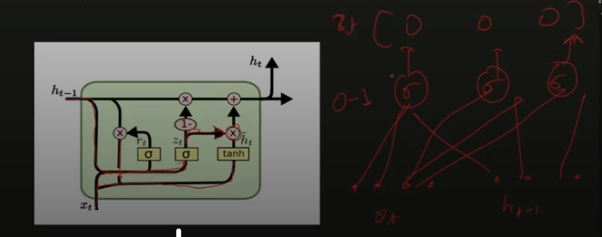

Now this z_t output is multiplied with h_t . If z_t value is 0 then this will make h_t zero.

And if z_t o/p is 1 then all the info is important. So z_t will act as a filter on h_t and then this info is added on h_t. Now if we say 2+3=5 then 5-3=2, so this is to take care of the fact that if z_t contains some data after filteration if that is not important then the data before filteration i.e. 1-z_t is important. So this is how it resets and update data.

So, reset gate reset info from previous timestamp . Update gate- update new info to stm on the basis of current timestamp information.

Here, in this code—

model = Sequential()

model.add(Embedding(8718, 100, input_length=17))

model.add(LSTM(150)) #--------------------------------------------- write GRU

model.add(Dense(8718, activation='softmax'))

------- Now single layer of GRU/LSTM many times result in overfitting. So try with different layers. Apply dropout. We can have stacked sequences of these layers . If we do return_sequence=True, then,

model = Sequential()

model.add(Embedding(input_dim=vocab_size, output_dim=5, input_length=max_length))

model.add(SimpleRNN(32,return_sequences=True) # recurrent dropout is same as dropout layer

model.add(SimpleRNN(32,return_sequences=True)

model.add(SimpleRNN(32,False)

# return_sequences=True means after every i/p , I want o/p.

model.add(Dense(3, activation='softmax'))

model.summary()

So like this u can also apply LSTM layer instead of SimpleRNN.

Next we have is Bi-directional RNN,Bidirectional LSTM and bidirectional GRU.

For this we need to understand seq 2 seq model. And then we will understand transformers.

Before gpt wwe had bert, this is already trained. So we use pretrained model.

This is what is gen ai.

Seq to seq 22nd.

So sequential data is the data passed in sequence. Eg RNN,LSTM and GRU. Now in them the sequential data is passed at different timestamps but when future i/p depends on past o/p then we will have to use bidirectional data. For eg. 1. Amazon is best website. 2. Amazon is best river. Now the future i/p here is best website which is deciding past o/p i.e. Amazon.

So how we will know what is Amazon . Its answer is at later timestamps. So in such kinds of data we use bidirectional data.

Next is Named Entity Recognition – It is basically assigning some names to some entities. For eg. in sentence, Ram is a good boy. Ram is a Person. Next, New Delhi is capital of India. So New Delhi and India are locations. These are the entities and we try to recognize them. So in above sentences, when Amazon is a river , it is recognized as location where as , if Amazon is a website, then it is recognized as an organization. So in the sentence Amazon is a best website, website word is coming at the last timestamp, which is deciding whether Amazon is a location or an organization.

In such cases we use bidirectional models.

Next when we r doing machine/language translation , we can use bidirectional model. Because words placing can , their actual meaning can be tricky.

In sentence Amazon is the website and Amazon is the river, we have 4 timestamps. So Amazon is what we will get to know at 4th timestamp. Now in 1 way model, based on model’s understanding, model can put Amazon under org/loc. Then is and the will come , their NER is None and website also None. So this is unidirectional. So if at t0 Amazon is given as location then it will be wrong. But with Bi-directional model, like-

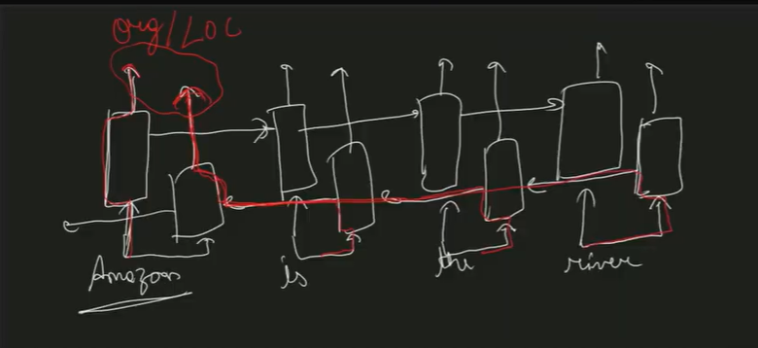

So o/p at the end will decide whether it should be an org/loc.

So bidirectional is when u pass ur sentence or data in reverse order to the model to process it from both directions. So basically we are processing both in Amazon is the river and River is the Amazon direction.

model = Sequential()

model.add(Embedding(8718, 100, input_length=17))

model.add(Bidirectional(LSTM(150,return_sequences=False)))

model.add(Dense(8718, activation='softmax'))

Now in seq-2-seq model we will learn unequal length.

In RNNs there are many kinds of sequential model i.e. 1-to-many, many-to-one,many-to-many.

In many-to-many equal length also called as Synchronous and unequal length called as Asynchronous eg Machine Translation problem. So Asynchronous example include encoder-decoder architecture, attention mechanism, self attention (i.e. Attention is all you need).

Seq-2-Seq model – Language translation – here i/p length might not be equal to o/p length. So here we r trying to understand encoder-decoder architecture.

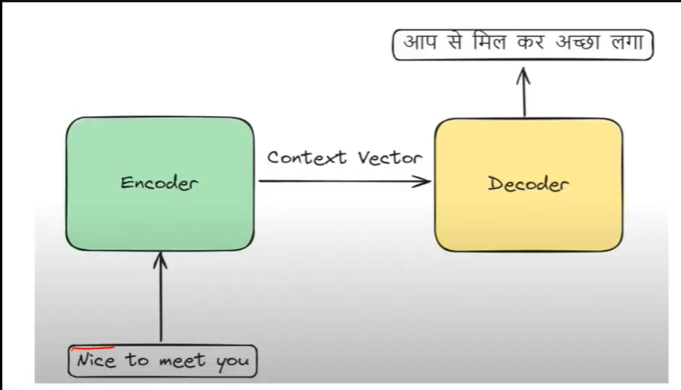

Now when the sentence is passed to an encoder, it stores in the form of some numbers or context vectors and same numbers it gives to the decoder which gives o/p corresponding to other language.

Encoder Decoder architecture is for unequal length translation.

Encoder block –

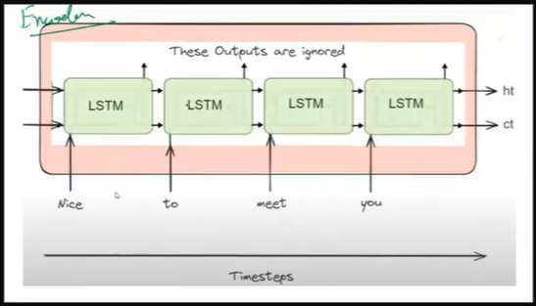

Instead of LSTM u can also use RNN or GRU, In the official research paper of encoder-decoder, LSTM is only used. Now here if we will do return_sequence=True , then we will get o/p in every timestamp.

Now,Nice to meet you corresponds to AAp se mil kar achcha laga. i.e. 4 words to 6 words. So the word-by-word o/p which is given as o/p is ignored and o/p at the end is stored. This is called as context vector.

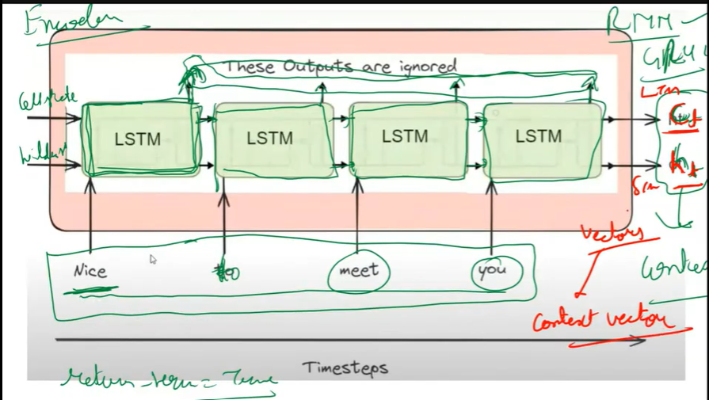

Now this context vector stores information regarding this complete data. Now this context vector we will send to the decoder an then we will get the o/p.

Now this is the decoder block. i.e.

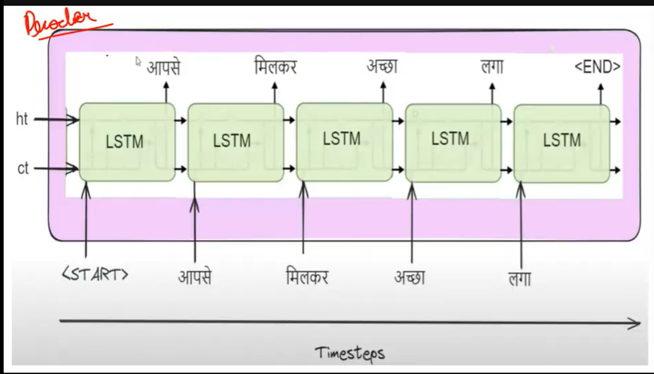

Now context vector c_t and h_t are the context vectors, comes from decoder block . So to this LSTM model, we will send start and with the o/p we will send end.

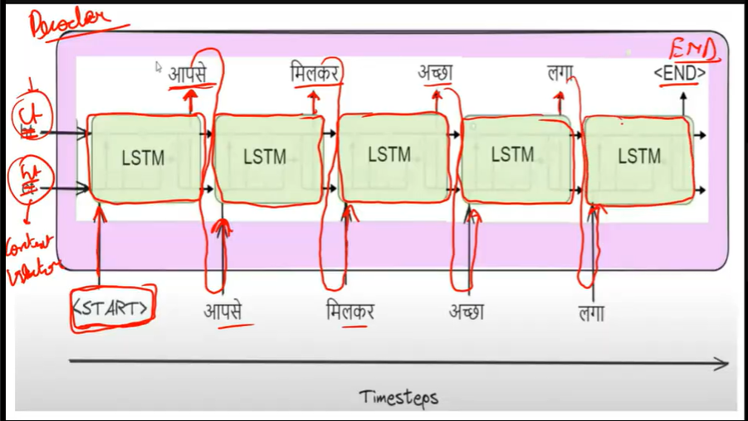

Now the o/p that will get stored at the endis Aapse milkar achcha laga.

Teacher Forcing in Encoder Decoder – While training model for English-to-hindi translation, and lets suppose aapse ki jagah model gave o/p tumse. Now this o/p is given as i/p to coming i/p. So if 1 o/p goes wrong the model will make all the other o/ps wrong.

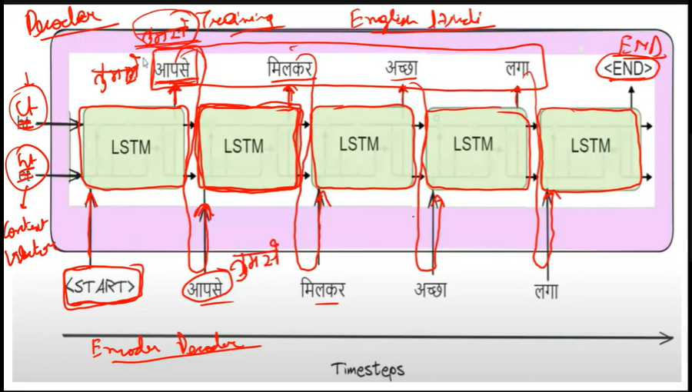

So for controlling this, the technique that we use is Teacher Forcing. And this happens during training. So this we can control by not giving model’s output at the next timestamp, instead, the actual i/p is given as i/p next to the timestamp.

So, the final architecture is like-

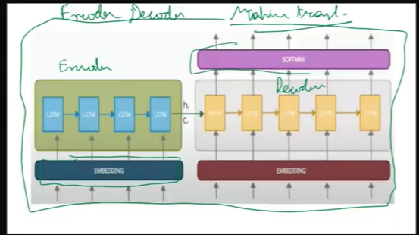

Here extra layers are embedding and softmax layers.

23rd July. --- Seq-2-Seq Attention Mechanism--

We will see machine translation, in colab using tpus.

Eng-to-hin-seq2seq.ipynb – go throught this. And u can customize it to deep architecture.

#-- mask_zero will make sure the length of all the sentences is 20 only.

Predicting model only on top 100 rows, because it has become very heavy.

Argmax will give the highest prob for each class.

In get_word extracting word from number. Index of these numbers we have got in predictions.

If the particular number is not present in tokenizer then we will get None.

Next is attention Mecahnism on the basis of which transformer is created.

So 1st understanding Attention Mechanism.

In encoder decoder architecture the problem is we r considering the sentence length of 20.

Now when this sentence length is more then 20, the translation o/p quality decrease.

This is so because , when the length of the sentence is more, it becomes difficult to store all the info in context vector. U can say the context vector is like a summary of the i/p.

The problem lies in its architecture only.

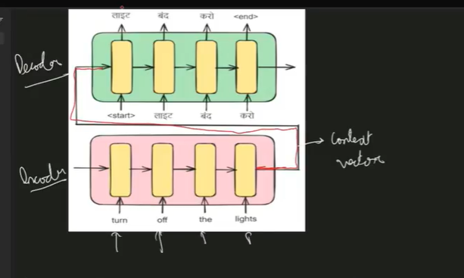

In the above diag, lights is the nearest word to the context vector. Then the, etc. So info of lights, the is available more to decoder then starting words.

So to deal with this problem attention mechanism is introduced. Light in hindi predict karne ke liye lights word pe zyada attention chahiye then turn off and vice versa for turn off.

So attention mechanism help in giving more importance to the part of input sentence which is making more sense for the o/p.

Now attention mechanism doesn’t have context vector in stead a NN layer ANN is added to act as attention head.

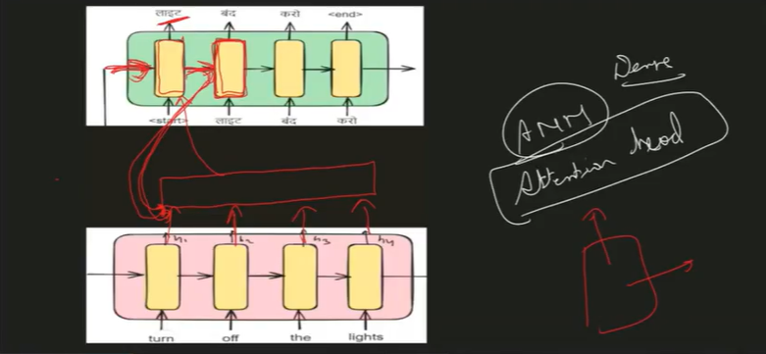

To predict the band word kiska zyada importance hai .

With the help of backpropogation weights of alpha is decided.

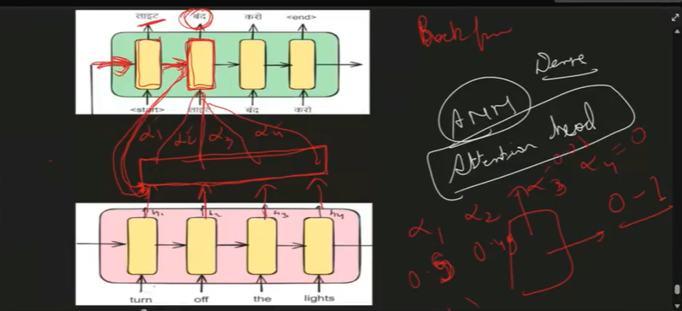

Transformers – Those who work on google brain are totally researched based company.

In lstm we have 3 gates – forget gate, input gate and output gate.

The forget gate is both problem and a solution. Now it is possible that in the 1st sentence we r talking about something and in coming 4-5 sentences not refrred about that thing at all and after that in 6th or 7th sentence, talking about that thing again. So model will forget about that and so its context doesn’t get build. And so it doent perform well.

So a totally new architecture, Transformer is build. Its research paper name is Attention Is All you Need.

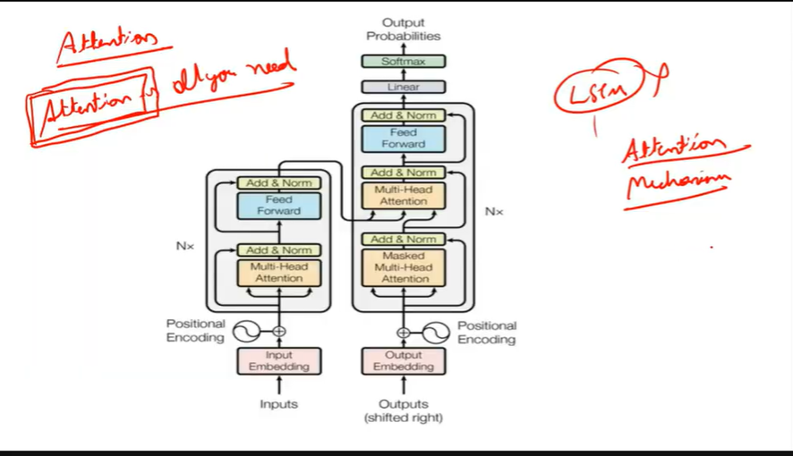

Now In the encoder decoder architecture, the drawback is, if I want to predict about light, then we will have to pay most of the attention to light only.

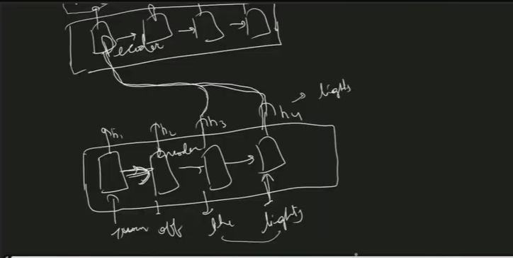

So send info from the lights only and not turn off where the is only here as helper so attention of the will be lesser than the attention of lights. Now each of this hidden layer is fully connected and gives as o/p some weights like alpha1, alpha2, alpha3 and alpha4 .

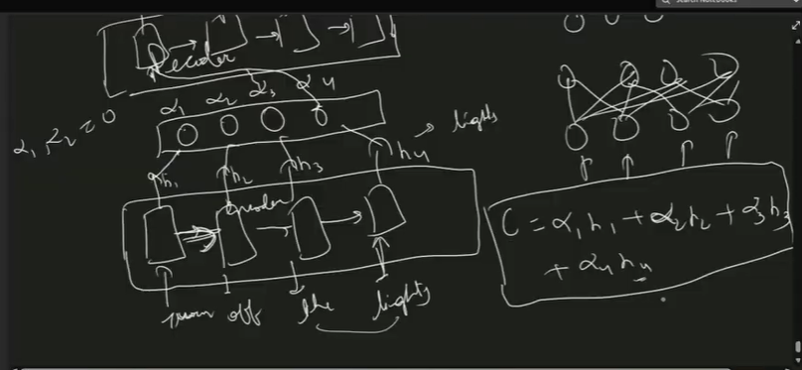

The highest weightage is of alpha4. This is attention.

So in transformer they have used attention mechanism called as self-attention.

The problem in nlp is to convert words into number, i.e. bag of words, tf-idf etc is used for this.

S1= I like football. S2=I hate football.

So unique words here are- [I,like,hate,football].

Then we will calculate the frequency . S1=[1,1,1], S2=[1,1,1]. This is bag of words.

Now the problem with it is as a human we can understand there is a difference in them.

So the problem with bow is based on freq it is converting the sentences. Same with tf-idf.

Now before transformaers embeddings were created nly once. And called as static embeddings.

Now consider a word apple – eat or use? Iphone has been developed by apple and orange is tasty.

Here apple is not a fruit. So if we will take old embeddings, then apple will be a fruit not company.

So the embeddings will be accordingly. What transformers create is a contextual embeddings.

For eg Money bank and river bank. The bank meaning is completely different in both the words. So the meaning of bank is decided on the basis of the word it is used with.

So transformers has self-attention. Its work is to understand the context in which the word is used finding meaning and accordingly converting it into numbers.

Google embeddings has a collection of 300 numbers.

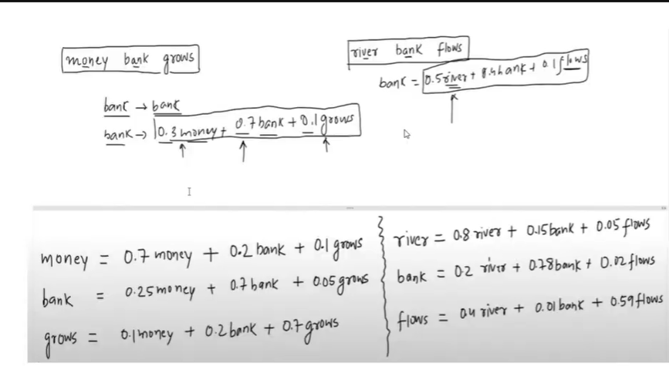

So self-attention is automatically deciding the weightage according to word.

So how this weightage or self-attention numbers are coming? – the maths here is—

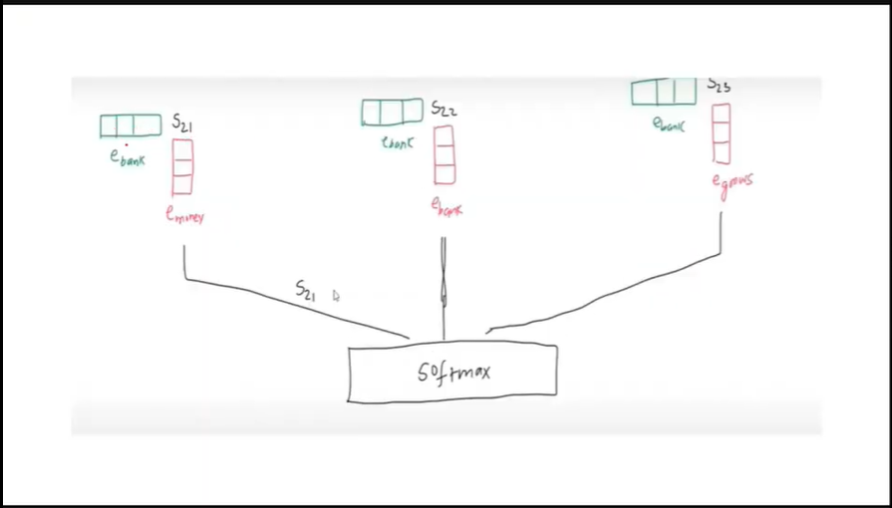

New embeddings of bank is the dot product of emoney,ebank and egrows.

Then the similarity between old embedding and new embedding is found. Now all these embeddings will be given to softmax which will give alpha or weight as o/p .

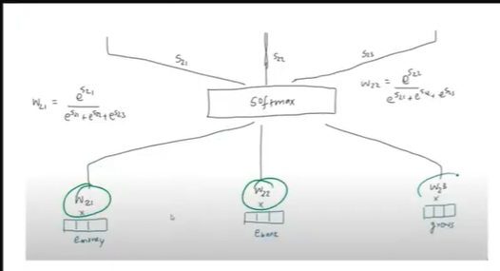

So this is how contextual embeddings gets created.

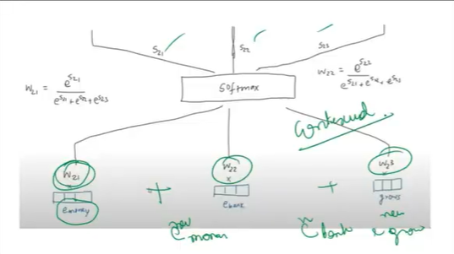

The flow diagram is like –

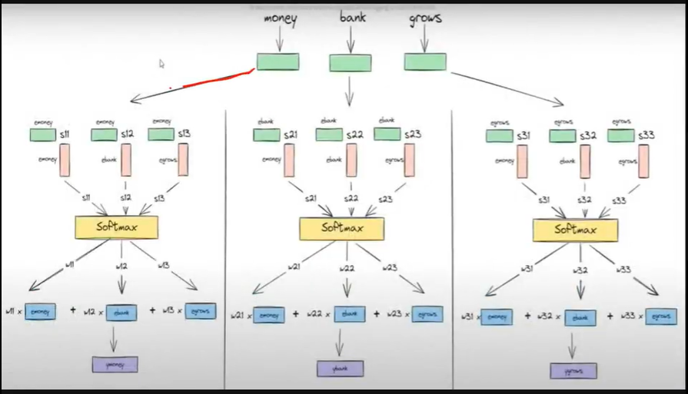

These embeddings are called as contextual embeddings.

So all the embeddings gets parallelly calculated. So,

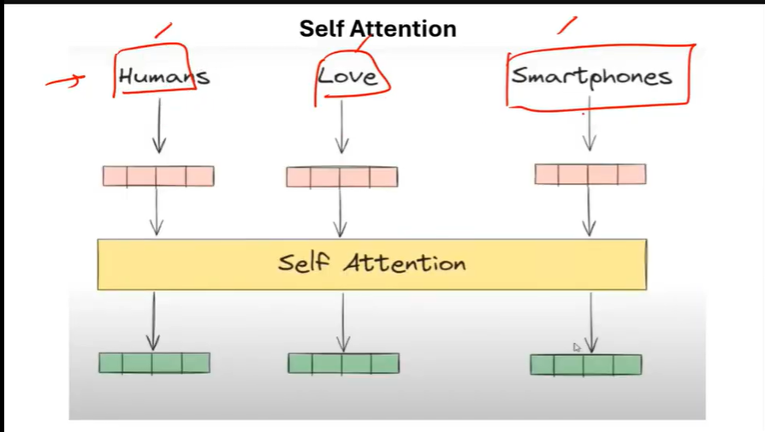

So self attention given new embeddings.

In the transformer architecture we have multiheaded attention, that means many many self attentions are applied.

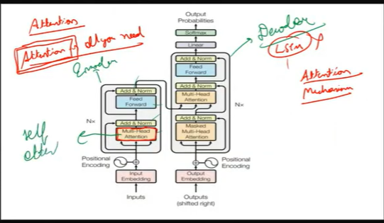

Where, multi headed attention produces multiple new embeddings , like-

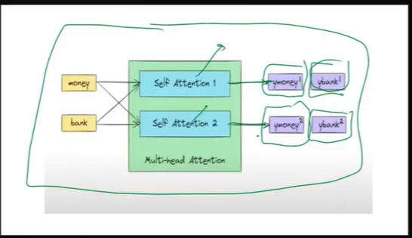

This is multihead attention.

Now the problem here is when we r sending something parallely like—

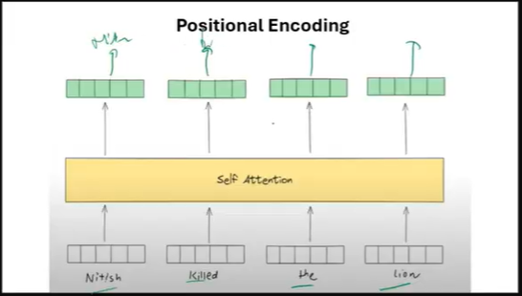

Then we r not sure that the 1st embedding to come out of softmax is Nitish only.

Nitish killed the lion can become the lion killed nitish.

So, this position is a very big problem. RNN and LSTM are sequential model so we don’t have this problem here , but it in transformer parallely inputs are given . So, positions are also maintained. For this positional encoding is applied using sin and cos. So embeddings are added with their position and after that sin or cos is applied to bring the o/p between -1 and 1.

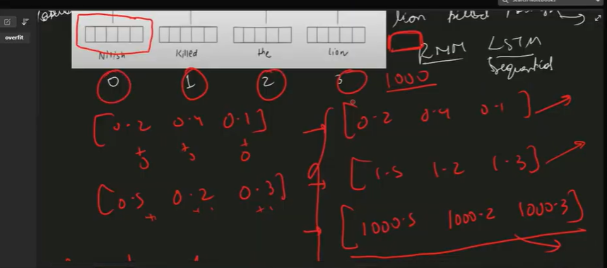

So if we will see transformer architecture—

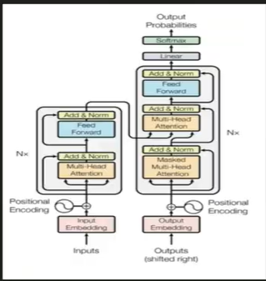

We have positional encoding . We take old embeddings, and add both the information and give to multiheaded attention and then it will give new embeddings.

So in transformer we have—encoder, decoder

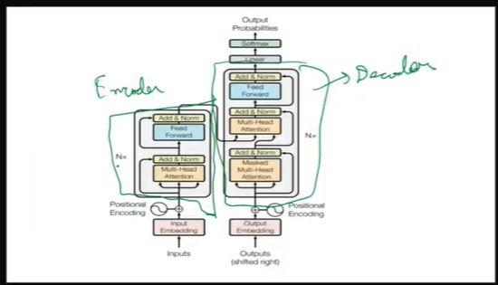

Nx is for any number of encoder decoder layer. In the official research paper they have used 6 decoder and encoder architecture. In encoder part we have multi head attention and feed forward NN.

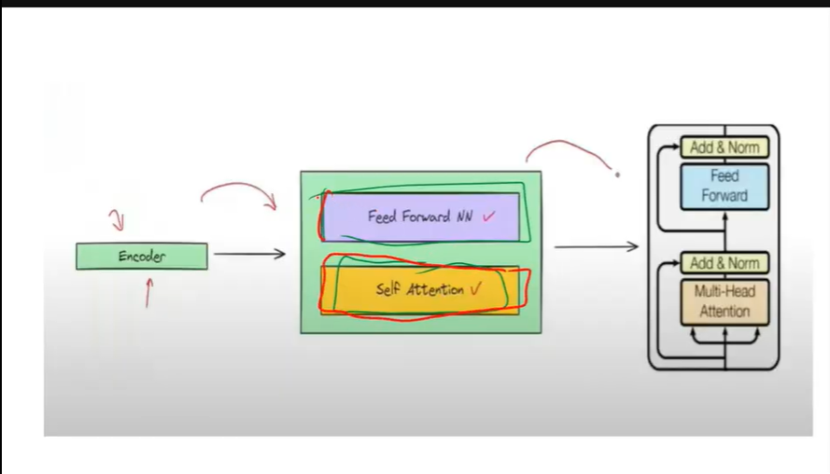

Add and norm is –

In transformers , self attention blocks gives contextual embeddings. Earlier the embeddings that we were using were static embeddings, but now according to context the embeddings will be generated.

For eg in the sentence, River bank flows and Money bank grows , bank has different meaning based on context. So apart from this we also have positional encoding because it is possible that when we pass a sentence River bank flows, the embedding for flows might come first, then river then bank.

i.e. the complete order is changed and we know that NLP is a sequential data. So for a sentence like Ankit is faster than Leela, it might become Leela is faster than Ankit. Then we have Multi-head attention i.e. self-attention only.

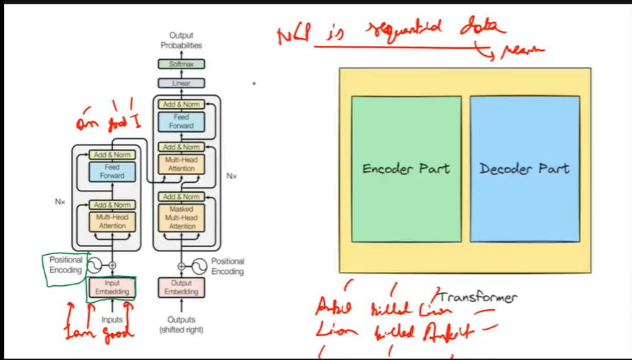

So next we will look at add and norm. This add and norm o/p goes as an input to deoder architecture.

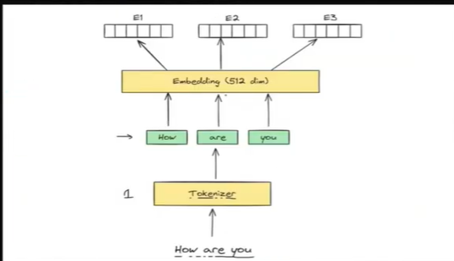

Lets suppose my sentence is how are you? So 1st we will tokenize it. So,3 tokens How , Are and you.

We will also take it architecture—

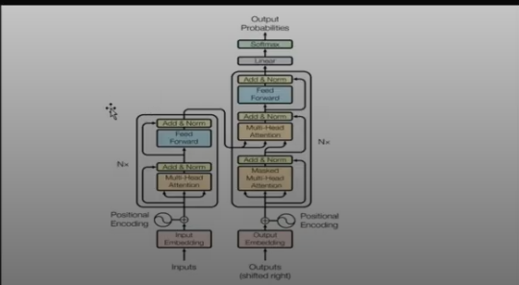

See the encoder part. Now after tokenization static embeddings of 512 dim is generated. This u can generate for all the tokens by word2vec or keras, or anything. Next adding positional encoding.

i.e.

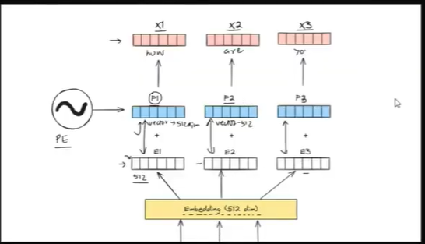

The positional encoding shape is of size of embedding. If embedding size is 512, then positional encoding size will also be same. Now after adding this , from the diag we got a new vector called as x1,x2 and x3. So coming to next step ie. Applying multi-head attention.

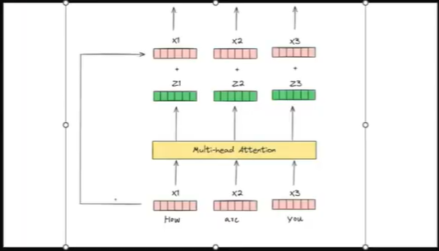

Now x1 is E+PE i.e embedding + positional encoding. Now this will go to multiple self attention. These embeddings are contextual embeddings i.e. z1,z2 and z3. Now it is possible that the positional encoding number got lost or changed completely. So in contextual embedding z1,z2 and z3 we again add PE+E. See the side arrow. So,the o/p of x1+z1 , x2+z2, x3+z3 will give contextual encoding + Positional encoding + old embeddings.

So we have added but what is this norm? Norm means performing normalization.

In image normalization in cnn, we divided the image by 255. Same in ANN to bring down to same scale. We need this here because all the embeddings are in range 0-1. And on adding values to this, the range can increase. So, normalizing again.

Now in the next layer we have feed forward neural network.

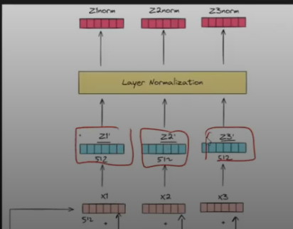

So after layer normalization, we r getting z1norm,z2norm,z3norm which is again in the range 0-1.

Now feed forward NN is like fully connected ANN network. The z1norm,z2norm,z3norm are stacked together and given to ANN.

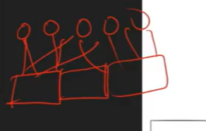

This will also give vectors as o/p whose shape will be same as that of input embeddins. Like

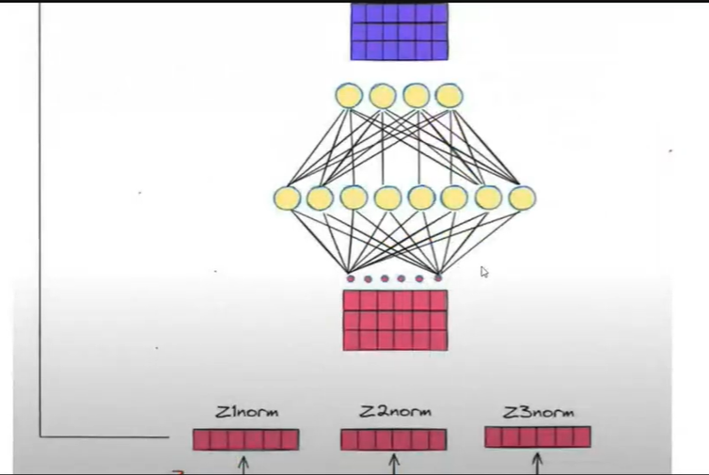

So ,

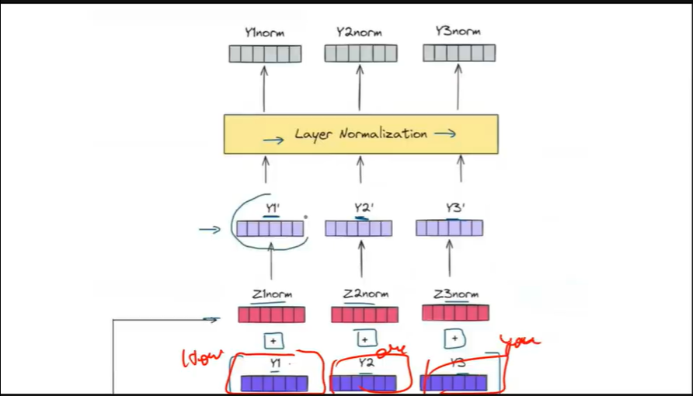

Y1’ Y2’ and Y3’ are the vectors for How are you? Now in the architecture ,this feed forward o/p is again added with add and norm o/p. i.e.

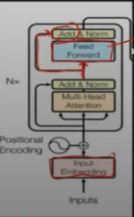

Now this addition is for just in case position encoding got missed then we can have positional encoding again. And then performing normalization again. So now this complete information is sent to decoder architecture. Now decoder has similar architecture.

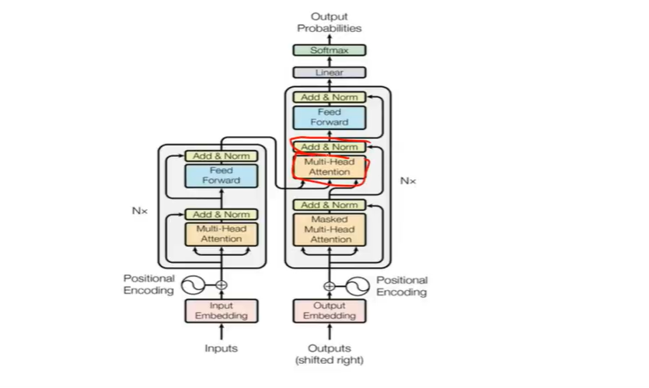

The different thing is masked multi-head attention.

Sentiment_BERT.ipynb – sentiment analysis using bert. – googleplaystore user reviews dataset.

RASA Chatbot 29th July

RASA Chatbot is an open source chat bot framework. It creates a bot that can chat with user.

RASA Pro is a paid version and has used transformer. And transformer uses GPU , so its costly.

RASA originally the free version which is an open-source framework, is based on ml and not transformers.

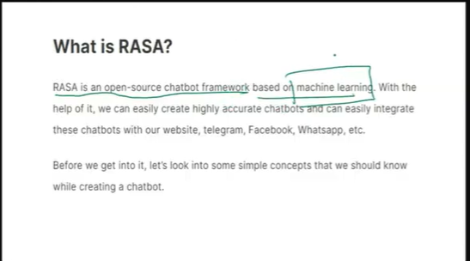

Few terminologies that we should must know before working with RASA chatbot—

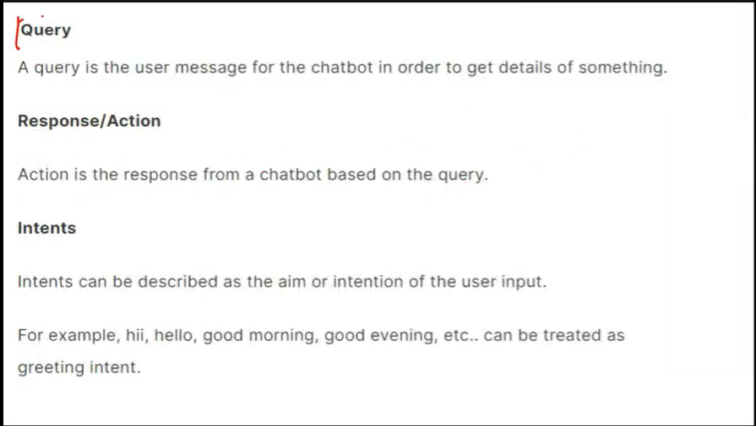

Intents is the short form for intention. So the meaning of a query or question asked.

So if I query I want to talk with customer care,then my intention is to talk. If I say I want to buy a laptop my intention is to buy something. I want to book a room.

So by knowing the intention in the query, we can make or train bot to give response or take some action.

For eg—

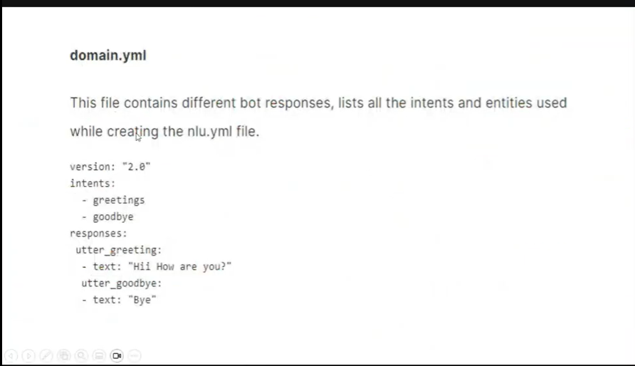

Open in colab notebook RASA_Initial_Chatbot.ipynb . 1st we will see how to start the RASA chatbot.

Then we will build the RASA chatbot. So RASA has many files like nlu.yml, domain.yml,stories.yml.

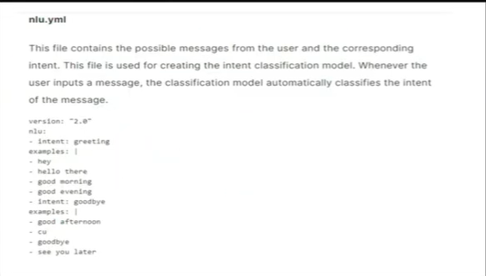

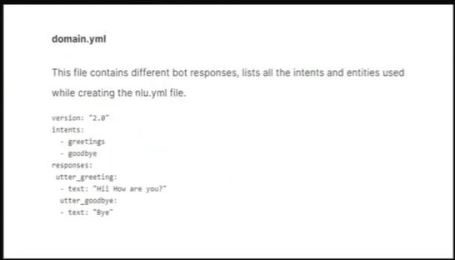

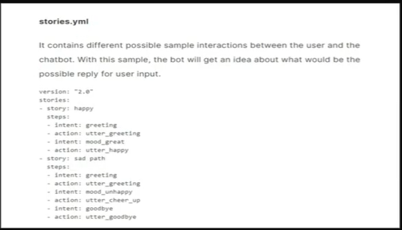

So goto google colab. It is old so require old python version i.e. around 3.5 and on laptop it could be a different version. So do in colab better. U can do it on cpu or gpu. Restart this session.

#--------------------------------------

anaconda prompt-- md demo--cd demo

conda create -n myenv python=3.7.6

conda activate myenv

pip install tensorflow

---- not required----pip install --upgrade pip setuptools wheel

pip install tensorflow

pip install ujson

pip install rasa

#--------------------------------------------

(myenv) C:\Users\itvedant>d:

(myenv) D:\>

(myenv) D:\>mkdir chatrasa

(myenv) D:\>cd chatrasa

(myenv) D:\chatrasa>

(myenv) D:\chatrasa>rasa init

bye

your input ->/stop-----------------brings out of chatbot

(myenv) D:\chatrasa>

So for making this chatbot a little more advanced, prepare a document which has faqs.

For eg . Problem Statement document in folder.

This is for a hotel room booking.

NLU.yml, domain.yml and stories.yml – we need these files to make changes.

The chatbot flow that we have seen earlier, is with the help of these 3 files only.

So, 1st understanding the steps.

1st we will create nlu.yml file. Then domain.yml and then stories.yml

Use of these files—NLU is natural language understanding—here we write down all the possible questions user can ask.

But when the questions are asked, the intent also plays a very important role.

Lets suppose user asks a question User: I want to book a room.

Then can you tell the user intention? The intention here is to book a room.

So in NLU, we describe Intent and all the possible questions that can describe that intent.

Now, inside data folder, we have nlu.yml file. i.e. D:\chatrasa\y\data

Double click on nlu.yml file. It will be opened.

Here we can see something like—

version: "3.1"

nlu:

- intent: greet

  examples: |

    - hey

    - hello

    - hi

    - hello there

    - good morning

    - good evening

    - moin

    - hey there

Here, intent’s name is greet. All the possible greetings that user can say to chatbot, that we have to mention here.

In our case, I want to book a room can be said as I need to book a room, etc.

Or I want to book a room for whole day.

So, if we create intent: book room, we have to write all the possible chats that might come.

U can have multiple intents.

So, in nlu.yml u r having questions or input from user.

Now, domain.yml contains bot’s response.

Next, rules and stories are kind of similar. U can use either of them.

Instead of rules, u can even create stories. Comparatively stories.yml is more important.

- rule: Say 'I am a bot' anytime the user challenges

  steps:

  - intent: bot_challenge

  - action: utter_iamabot

In rules.yml , it is mentioned, if something like this is given by user, then the response will be like what.

Always write response of the bot in utter_ some_name.

Double click and Open stories.yml . Here you will define the flow of chat.

Like what chatbot will say and what user will reply. Etc.

For eg we can have in our case story of booking and cancellation.

So in stories.yml we mention intent name and action name.

So in rasa shell try—

I am sad and in stories.yml check the flow.

Now lets suppose in utter_cheer_up . we changed image path. For eg—

Search cute puppy in internet, copy any image path and change the path ,,there.

So after changes train the model again.

(myenv) D:\chatrasa>rasa train

And ready the agent to talk again.

(myenv) D:\chatrasa>rasa shell

Rules.yml is best for 1 intent 1 action. But in stories,yml u can define flow.

So the steps are—1st create NLU.yml, then Domain.yml and then Stories.yml

So 1st updating NLU.yml. Open nlu.yml in vs code. We don’t need version so u can delete

version: "3.1".

In colab if u want to update any file, then command is

======= %%writefile data/nlu.yml and copy complete code of nlu.yml inside colab cell

For our case, nlu.yml is opened in vs code. In this file we have some basic intents, which we will keep.

Instead we will add new intents.

Since, user’s 1st intent is to book a room. So, Just add—

- intent: book_room

  examples: |

    - i want to book a room

    - i need a room

    - i am looking for a room

    - is room empty

    - book a room

    - book a room for a night

    - room booking

So now our intent in nlu.yml file is created. Next we will create response for this intent in

Domain.yml file. Here we need to mention 2 things. 1. Name of the intent 2. Response from the chatbot.

So after – bot_challenge , write—

  - mood_unhappy

  - bot_challenge

  - book_room

  - num_room

  - simple

  - deluxe

Next below intent is response. So in responses write—

responses:

  utter_simple:

    - text: "Great, you have chosen Simple room."

  utter_deluxe:

    - text: "Great, you have chosen Deluxe room."

  utter_extra_help:

    - text: "Is there any thing else I can help you with?"

  utter_num_room:

    - text: "Okay, there are two types of rooms available i.e. Simple room and Deluxe room. Which type of room you want to book?"

  utter_book_room:

  - text: "Okay, I will book a room for you. Please tell me how many rooms would you like to book."

  utter_greet:

  - text: "Hey! How are you?"

So while naming response make sure u r writing utter_intent_name.

So now, if bot asks how many rooms? Then user says lets suppose, 2 rooms or 3 rooms.

So, for every user answer , create an intent in nlu.yml and response in domain.yml.

So, go to nlu.yml. Write intent—

- intent: num_room

  examples: |

    - I need 2 rooms

    - is 3 room available

    - 4 rooms

    - can i get the 3 rooms

    - I want 3 rooms.

    - I need two rooms.

    - Are three rooms available?

    - I'd like to book four rooms.

    - Can I get three rooms?

    - I want to reserve three rooms.

So till now the flow is like –

User : I want to book rooms

Bot : How many rooms?

User : 3 rooms

Bot : "Okay, there are two types of rooms available i.e. Simple room and Deluxe room. Which type of room you want to book?"

---

So in the domain.yml create this response.

In domain.yml , 1st give intent name i.e.

num_room

And for response utter_num_room and give text.

Next, the user will give answer to bot—So,

User : I want to book a Simple room.

So, creating intent for user in Simple and Deluxe in nlu.yml

- intent: simple

  examples: |

    - i need simple room

    - i want simple room

    - simple room

    - i am looking for simple room

    - can i get the simple rooms

    - I want to book a simple room.

- intent: deluxe

  examples: |

    - i need deluxe room

    - i want deluxe room

    - deluxe rooms

    - can i get the deluxe rooms

    - i am looking for deluxe rooms

    - I want to book a deluxe room.

Now the bot will give response in domain.yml like – Great U have chosen Simple Room.

After this response, bot will also say – Is there anything else?

Then user will say yes or no.

So like this our story is built.

So in domain.yml, creating responses – utter_simple, utter_deluxe and utter_extra_help.

Utter_extra_help is added just as response because this will be bot’s response. So that’s

Why intents are not mentioned for it.

Next, making changes in stories.yml.

stories:

- story: book_simple_room

  steps:

  - intent: greet

  - action: utter_greet

  - intent: book_room

  - action: utter_book_room

  - intent: num_room

  - action: utter_num_room

  - intent: simple

  - action: utter_simple

  - action: utter_extra_help

- story: book_deluxe_room

  steps:

  - intent: greet

  - action: utter_greet

  - intent: book_room

  - action: utter_book_room

  - intent: num_room

  - action: utter_num_room

  - intent: deluxe

  - action: utter_deluxe

  - action: utter_extra_help

- story: happy path

Next save all these 3 files.

Your input -> /stop

2025-06-18 11:21:57 INFO root - Killing Sanic server now.

2025-06-18 11:21:57 ERROR asyncio - Task was destroyed but it is pending!

task: <Task pending coro=<ctrlc_workaround_for_windows.<locals>.stay_active() running at C:\Users\hp\.conda\envs\myenv\lib\site-packages\sanic\compat.py:79> wait_for=<Future pending cb=[<TaskWakeupMethWrapper object at 0x0000015A5265F618>()]>>

(myenv) D:\chatrasa>rasa train

Lets suppose we will try Simple room story.

U can create more intents, reading these intents.

Opening stories.yml on side,

rasa shell

U : hi

B:

U: I want to book a room.

B:

U: I want to book 3 rooms.

B:

U: Simple room

B:

For user intent No, u can add intent: deny and in storeies, bot will say goodbye.